**WEEK-2: PL/SQL**

## **Exercise-2 Error Handling**

**Question-1:** Write a stored procedure **SafeTransferFunds** that transfers funds between two accounts. Ensure that if any error occurs (e.g., insufficient funds), an appropriate error message is logged and the transaction is rolled back

**Solution:**

CREATE OR REPLACE PROCEDURE SafeTransferFunds (

p_from_account_id IN NUMBER,

p_to_account_id IN NUMBER,

p_amount IN NUMBER

) IS

v_balance NUMBER;

BEGIN

SELECT Balance INTO v_balance

FROM Accounts

WHERE AccountID = p_from_account_id;

IF v_balance < p_amount THEN

RAISE_APPLICATION_ERROR(-20001, 'Insufficient funds in source account.');

END IF;

UPDATE Accounts

SET Balance = Balance - p_amount

WHERE AccountID = p_from_account_id;

UPDATE Accounts

SET Balance = Balance + p_amount

WHERE AccountID = p_to_account_id;

COMMIT;

DBMS_OUTPUT.PUT_LINE('Transfer successful.');

EXCEPTION

WHEN OTHERS THEN

ROLLBACK;

DBMS_OUTPUT.PUT_LINE('Error: ' || SQLERRM);

END;

/

**Output:**

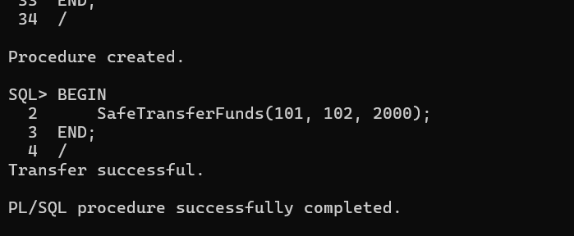

**Question-2:** Write a stored procedure **UpdateSalary** that increases the salary of an employee by a given percentage. If the employee ID does not exist, handle the exception and log an error message.

**Solution:**

CREATE OR REPLACE PROCEDURE UpdateSalary (

p_employee_id IN NUMBER,

p_percentage IN NUMBER

) IS

BEGIN

UPDATE Employees

SET Salary = Salary + (Salary * p_percentage / 100)

WHERE EmployeeID = p_employee_id;

IF SQL%ROWCOUNT = 0 THEN

RAISE_APPLICATION_ERROR(-20002, 'Employee not found.');

END IF;

COMMIT;

DBMS_OUTPUT.PUT_LINE('Salary updated.');

EXCEPTION

WHEN OTHERS THEN

ROLLBACK;

DBMS_OUTPUT.PUT_LINE('Error: ' || SQLERRM);

END;

/

**Output:**

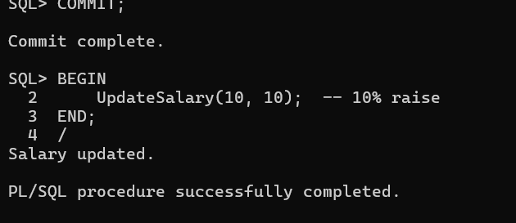

**Question-3:** Write a stored procedure **AddNewCustomer** that inserts a new customer into the Customers table. If a customer with the same ID already exists, handle the exception by logging an error and preventing the insertion.

**Solution:**

CREATE OR REPLACE PROCEDURE AddNewCustomer (

p_customer_id IN NUMBER,

p_name IN VARCHAR2,

p_dob IN DATE,

p_balance IN NUMBER,

p_isvip IN VARCHAR

) IS

BEGIN

INSERT INTO Customers (CustomerID, Name, DOB, Balance, LastModified,isvip)

VALUES (p_customer_id, p_name, p_dob, p_balance, SYSDATE,’true’);

COMMIT;

DBMS_OUTPUT.PUT_LINE('Customer added successfully.');

EXCEPTION

WHEN DUP_VAL_ON_INDEX THEN

DBMS_OUTPUT.PUT_LINE('Error: Customer with ID ' || p_customer_id || ' already exists.');

WHEN OTHERS THEN

DBMS_OUTPUT.PUT_LINE('Unexpected error: ' || SQLERRM);

ROLLBACK;

END;

/

BEGIN

AddNewCustomer(301, 'VIP Customer', TO_DATE('1960-01-15', 'YYYY-MM-DD'), 20000, 'True');

END;

/

**Output:**

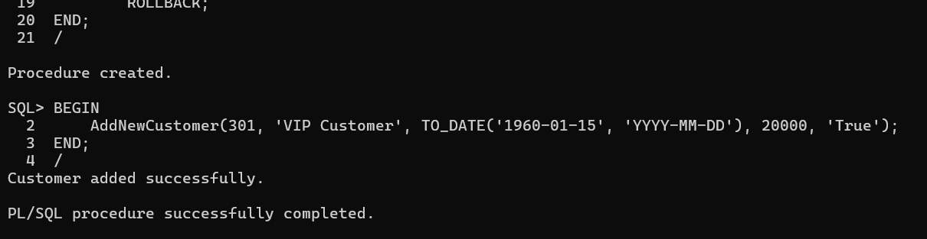

**Exercise 4: Functions**

**Question-1:** Write a function CalculateAge that takes a customer's date of birth as input and returns their age in years.

**Solution:**

CREATE OR REPLACE FUNCTION CalculateAge (

p_dob IN DATE

) RETURN NUMBER IS

v_age NUMBER;

BEGIN

v_age := TRUNC(MONTHS_BETWEEN(SYSDATE, p_dob) / 12);

RETURN v_age;

END;

/

SELECT CalculateAge(TO_DATE('1990-07-20', 'YYYY-MM-DD')) AS Age FROM DUAL;

**Output:**

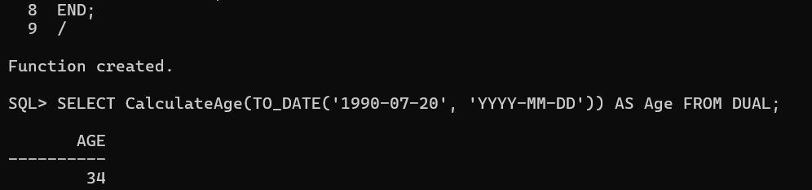

**Question-2:** Write a function **CalculateMonthlyInstallment** that takes the loan amount, interest rate, and loan duration in years as input and returns the monthly installment amount.

**Solution:**

CREATE OR REPLACE FUNCTION CalculateMonthlyInstallment (

p_loan_amount IN NUMBER,

p_annual_rate IN NUMBER,

p_years IN NUMBER

) RETURN NUMBER IS

v_monthly_rate NUMBER;

v_months NUMBER;

v_emi NUMBER;

BEGIN

v_monthly_rate := p_annual_rate / (12 * 100); -- Convert annual rate to monthly decimal

v_months := p_years * 12;

v_emi := (p_loan_amount * v_monthly_rate * POWER(1 + v_monthly_rate, v_months)) /

(POWER(1 + v_monthly_rate, v_months) - 1);

RETURN ROUND(v_emi, 2);

END;

/

**PL/SQL Block to Call:**

DECLARE

v_loan_amount Loans.LoanAmount%TYPE;

v_interest_rate Loans.InterestRate%TYPE;

v_start_date Loans.StartDate%TYPE;

v_end_date Loans.EndDate%TYPE;

v_years NUMBER;

v_emi NUMBER;

BEGIN

FOR rec IN (

SELECT LoanID, LoanAmount, InterestRate, StartDate, EndDate

FROM Loans

) LOOP

-- Calculate duration in years

v_years := ROUND(MONTHS_BETWEEN(rec.EndDate, rec.StartDate) / 12, 1);

-- Calculate EMI

v_emi := CalculateMonthlyInstallment(rec.LoanAmount, rec.InterestRate, v_years);

-- Output result

DBMS_OUTPUT.PUT_LINE('Loan ID: ' || rec.LoanID ||

' | EMI: ' || v_emi ||

' | Duration: ' || v_years || ' years');

END LOOP;

END;

/

**Output:**

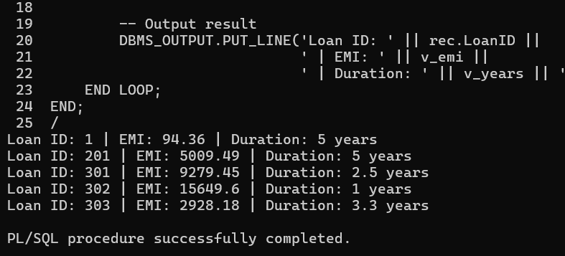

**Question-3:** Write a function **HasSufficientBalance** that takes an account ID and an amount as input and returns a boolean indicating whether the account has at least the specified amount

**Solution:**

CREATE OR REPLACE FUNCTION HasSufficientBalance (

p_account_id IN NUMBER,

p_required_amount IN NUMBER

) RETURN BOOLEAN IS

v_balance NUMBER;

BEGIN

SELECT Balance INTO v_balance

FROM Accounts

WHERE AccountID = p_account_id;

RETURN v_balance >= p_required_amount;

EXCEPTION

WHEN NO_DATA_FOUND THEN

RETURN FALSE;

WHEN OTHERS THEN

RETURN FALSE;

END;

/

**PL/SQL Block to Call:**

DECLARE

result BOOLEAN;

BEGIN

result := HasSufficientBalance(101, 500);

IF result THEN

DBMS_OUTPUT.PUT_LINE('Sufficient balance.');

ELSE

DBMS_OUTPUT.PUT_LINE('Insufficient balance.');

END IF;

END;

/

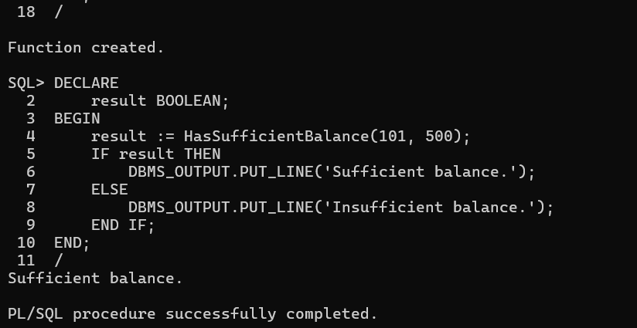**Output:**

### Exercise 5: Triggers

**Question-1:** Write a trigger UpdateCustomerLastModified that updates the LastModified column of the Customers table to the current date whenever a customer's record is updated.

**Solution:**

CREATE OR REPLACE TRIGGER UpdateCustomerLastModified

BEFORE UPDATE ON Customers

FOR EACH ROW

BEGIN

:NEW.LastModified := SYSDATE;

END;

/

**Output:**

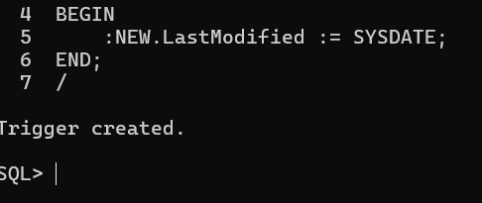

**Question-2:** Write a trigger **LogTransaction** that inserts a record into an AuditLog table whenever a transaction is inserted into the Transactions table.

**Solution:**

**Step 1: Create AuditLog table:**

CREATE TABLE AuditLog (

LogID NUMBER PRIMARY KEY,

TransactionID NUMBER,

LogDate DATE,

Message VARCHAR2(200)

);

**Step 2: Create Trigger:**

CREATE OR REPLACE TRIGGER LogTransaction

AFTER INSERT ON Transactions

FOR EACH ROW

BEGIN

INSERT INTO AuditLog (LogID, TransactionID, LogDate, Message)

VALUES (

AuditLog_Seq.NEXTVAL,

:NEW.TransactionID,

SYSDATE,

'Transaction logged for account ' || :NEW.AccountID

);

END;

/

**Output:**

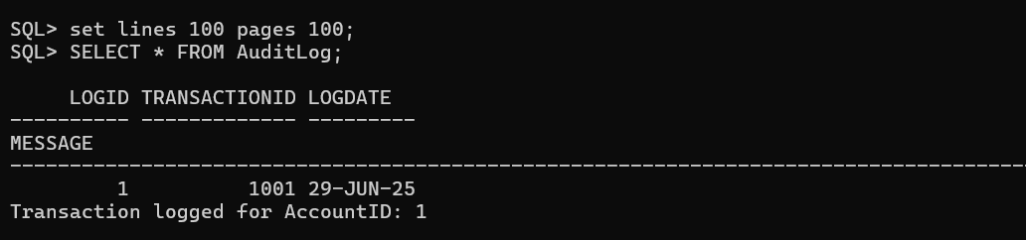

**Question-3:** Write a trigger CheckTransactionRules that ensures withdrawals do not exceed the balance and deposits are positive before inserting a record into the Transactions table.

**Solution:**

CREATE OR REPLACE TRIGGER CheckTransactionRules

BEFORE INSERT ON Transactions

FOR EACH ROW

DECLARE

v_balance NUMBER;

BEGIN

SELECT Balance INTO v_balance

FROM Accounts

WHERE AccountID = :NEW.AccountID;

IF :NEW.TransactionType = 'Withdrawal' AND :NEW.Amount > v_balance THEN

RAISE_APPLICATION_ERROR(-20001, 'Withdrawal exceeds account balance.');

ELSIF :NEW.TransactionType = 'Deposit' AND :NEW.Amount <= 0 THEN

RAISE_APPLICATION_ERROR(-20002, 'Deposit amount must be positive.');

END IF;

END;

/

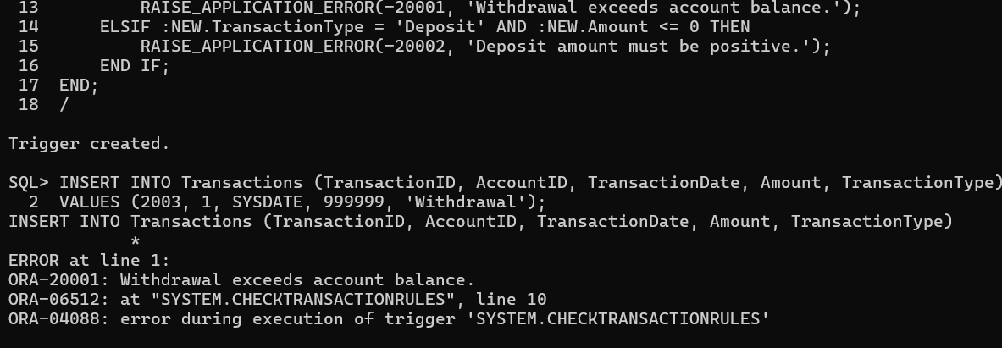**Output:**

### Exercise 6: Cursors

**Question-1:** Write a PL/SQL block using an explicit cursor **Generate Monthly Statements** that retrieves all transactions for the current month and prints a statement for each customer.

**Solution:**

DECLARE

CURSOR txn_cursor IS

SELECT c.Name, t.AccountID, t.Amount, t.TransactionType, t.TransactionDate

FROM Customers c

JOIN Accounts a ON c.CustomerID = a.CustomerID

JOIN Transactions t ON a.AccountID = t.AccountID

WHERE TO_CHAR(t.TransactionDate, 'MM-YYYY') = TO_CHAR(SYSDATE, 'MM-YYYY')

ORDER BY c.CustomerID;

BEGIN

FOR rec IN txn_cursor LOOP

DBMS_OUTPUT.PUT_LINE('Customer: ' || rec.Name ||

', Account: ' || rec.AccountID ||

', ' || rec.TransactionType ||

' of ₹' || rec.Amount ||

' on ' || TO_CHAR(rec.TransactionDate, 'DD-Mon-YYYY'));

END LOOP;

END;

/

**Output:**

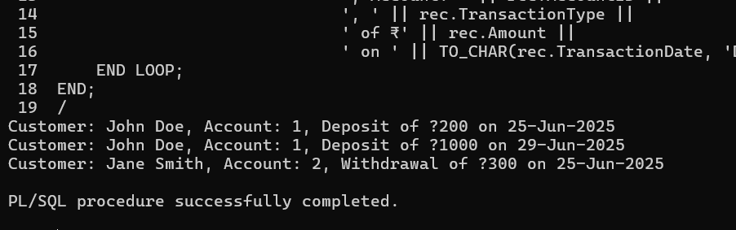

**Question-2:** Write a PL/SQL block using an explicit cursor **ApplyAnnualFee** that deducts an annual maintenance fee from the balance of all accounts.

**Solution:**

DECLARE

CURSOR acc_cursor IS

SELECT AccountID, Balance FROM Accounts;

v_fee CONSTANT NUMBER := 250;

BEGIN

FOR rec IN acc_cursor LOOP

IF rec.Balance >= v_fee THEN

UPDATE Accounts

SET Balance = Balance - v_fee

WHERE AccountID = rec.AccountID;

END IF;

END LOOP;

COMMIT;

DBMS_OUTPUT.PUT_LINE('Annual maintenance fee applied.');

END;

/

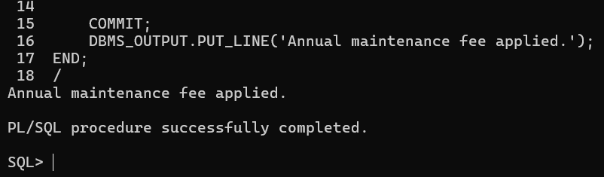**Output:**

**Question-3:** Write a PL/SQL block using an explicit cursor Update Loan InterestRates that fetches all loans and updates their interest rates based on the new policy.

**Solution:**

DECLARE

CURSOR loan_cursor IS

SELECT LoanID, InterestRate FROM Loans;

v_discount CONSTANT NUMBER := 0.5;

BEGIN

FOR rec IN loan_cursor LOOP

UPDATE Loans

SET InterestRate = rec.InterestRate - v_discount

WHERE LoanID = rec.LoanID;

END LOOP;

COMMIT;

DBMS_OUTPUT.PUT_LINE('Interest rates updated as per new policy.');

END;

/

**Output:**

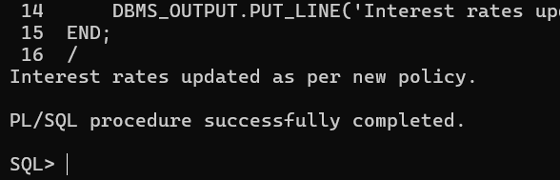

### Exercise 7: Packages

**Question-1:** Create a package **CustomerManagement** with procedures for adding a new customer, updating customer details, and a function to get customer balance.

**Solution:**

CREATE OR REPLACE PACKAGE CustomerManagement IS

PROCEDURE AddCustomer(

p_id NUMBER,

p_name VARCHAR2,

p_dob DATE,

p_balance NUMBER,

p_isvip VARCHAR2

);

PROCEDURE UpdateCustomerName(p_id NUMBER, p_new_name VARCHAR2);

FUNCTION GetCustomerBalance(p_id NUMBER) RETURN NUMBER;

END;

/

CREATE OR REPLACE PACKAGE BODY CustomerManagement IS

PROCEDURE AddCustomer(p_id NUMBER, p_name VARCHAR2, p_dob DATE, p_balance NUMBER, p_isvip VARCHAR2) IS

BEGIN

INSERT INTO Customers (CustomerID, Name, DOB, Balance, LastModified, IsVIP)

VALUES (p_id, p_name, p_dob, p_balance, SYSDATE, p_isvip);

COMMIT;

END;

PROCEDURE UpdateCustomerName(p_id NUMBER, p_new_name VARCHAR2) IS

BEGIN

UPDATE Customers SET Name = p_new_name WHERE CustomerID = p_id;

COMMIT;

END;

FUNCTION GetCustomerBalance(p_id NUMBER) RETURN NUMBER IS

v_balance NUMBER;

BEGIN

SELECT Balance INTO v_balance FROM Customers WHERE CustomerID = p_id;

RETURN v_balance;

END;

END;

/

**Output:**

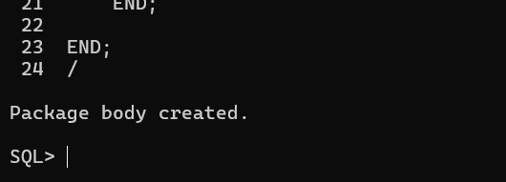

**Question-2:** Write a package **EmployeeManagement** with procedures to hire new employees, update employee details, and a function to calculate annual salary.

**Solution:**

CREATE OR REPLACE PACKAGE EmployeeManagement IS

PROCEDURE HireEmployee(

p_id NUMBER,

p_name VARCHAR2,

p_position VARCHAR2,

p_salary NUMBER,

p_dept VARCHAR2,

p_hiredate DATE

);

PROCEDURE UpdateEmployeeDetails(p_id NUMBER, p_salary NUMBER, p_dept VARCHAR2);

FUNCTION CalculateAnnualSalary(p_id NUMBER) RETURN NUMBER;

END;

/

CREATE OR REPLACE PACKAGE BODY EmployeeManagement IS

PROCEDURE HireEmployee(p_id NUMBER, p_name VARCHAR2, p_position VARCHAR2, p_salary NUMBER, p_dept VARCHAR2, p_hiredate DATE) IS

BEGIN

INSERT INTO Employees (EmployeeID, Name, Position, Salary, Department, HireDate)

VALUES (p_id, p_name, p_position, p_salary, p_dept, p_hiredate);

COMMIT;

END;

PROCEDURE UpdateEmployeeDetails(p_id NUMBER, p_salary NUMBER, p_dept VARCHAR2) IS

BEGIN

UPDATE Employees SET Salary = p_salary, Department = p_dept WHERE EmployeeID = p_id;

COMMIT;

END;

FUNCTION CalculateAnnualSalary(p_id NUMBER) RETURN NUMBER IS

v_salary NUMBER;

BEGIN

SELECT Salary INTO v_salary FROM Employees WHERE EmployeeID = p_id;

RETURN v_salary * 12;

END;

END;

/

**Output:**

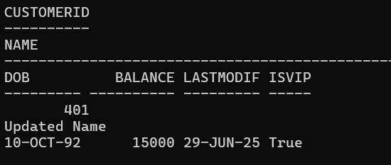

**Question-3:** Create a package **AccountOperations** with procedures for opening a new account, closing an account, and a function to get the total balance of a customer across all accounts.

**Solution:**

CREATE OR REPLACE PACKAGE AccountOperations IS

PROCEDURE OpenAccount(

p_accid NUMBER,

p_custid NUMBER,

p_type VARCHAR2,

p_balance NUMBER

);

PROCEDURE CloseAccount(p_accid NUMBER);

FUNCTION GetCustomerTotalBalance(p_custid NUMBER) RETURN NUMBER;

END;

/

CREATE OR REPLACE PACKAGE BODY AccountOperations IS

PROCEDURE OpenAccount(p_accid NUMBER, p_custid NUMBER, p_type VARCHAR2, p_balance NUMBER) IS

BEGIN

INSERT INTO Accounts (AccountID, CustomerID, AccountType, Balance, LastModified)

VALUES (p_accid, p_custid, p_type, p_balance, SYSDATE);

COMMIT;

END;

PROCEDURE CloseAccount(p_accid NUMBER) IS

BEGIN

DELETE FROM Accounts WHERE AccountID = p_accid;

COMMIT;

END;

FUNCTION GetCustomerTotalBalance(p_custid NUMBER) RETURN NUMBER IS

v_total NUMBER;

BEGIN

SELECT SUM(Balance) INTO v_total FROM Accounts WHERE CustomerID = p_custid;

RETURN NVL(v_total, 0);

END;

END;

/

**Output:**

